

**Wireframe Document**

**Heart Disease Diagnostic Analysis**

**Revision Number: 1.0**

**Last date of revision: 18/10/2022**

**SOURAV DEY**

**Document Control**

|  |  |  |  |
| --- | --- | --- | --- |
| **Date Issued** | **Version** | **Description** | **Author** |
| 19th october 2022 | 1.0 | Complete version of Wireframe Document | Sourav Dey |
|  |  |  |  |
|  |  |  |  |

**We Performed Exploratory Data Analysis on Jupyter Notebook and then created a Power BI Desktop Dashboard.**

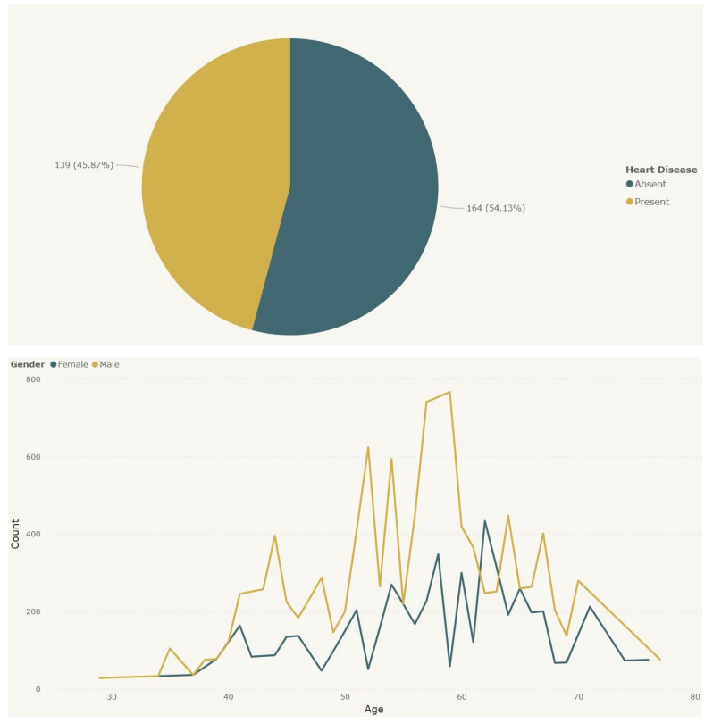

**➢ 45.87% People suffering from heart disease.**

**➢ Elderly Aged Men are more (50 to 60 Years) and Females are more in 55 to 65 Years Category**

**2. Who Suffer from Heart Disease?**

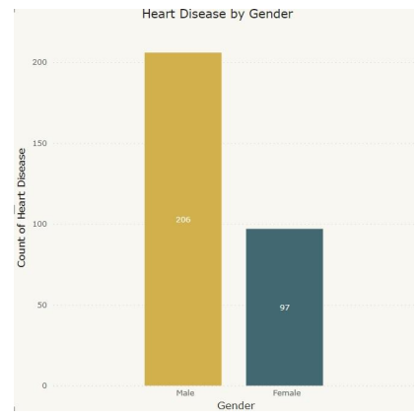

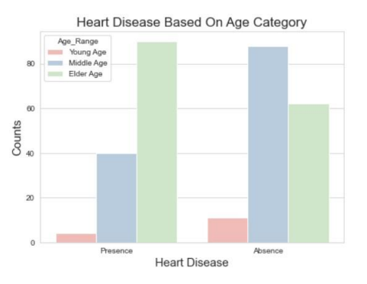

**➢ Males are more prone to heart disease.**

**➢ Elderly Aged People are more prone to heart disease.**

**3. What symptoms people experience in heart disease**

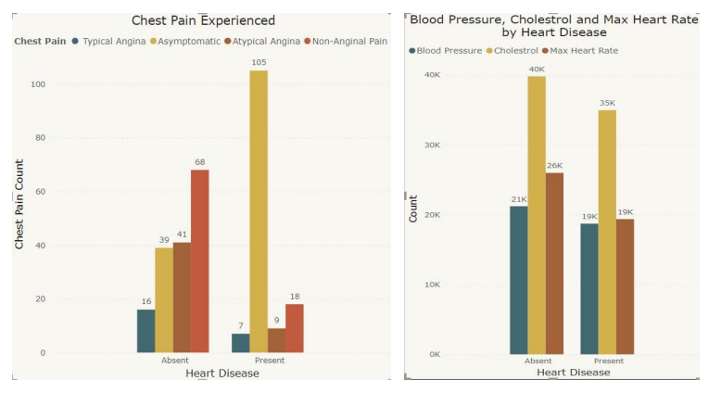

➢ It seems people having asymptomatic chest pain have a higher chance of heart disease.

➢ Asymptomatic Chest pain means neither causing nor exhibiting symptoms of heart disease.

➢ It seems high number of cholesterol level in people having heart disease.

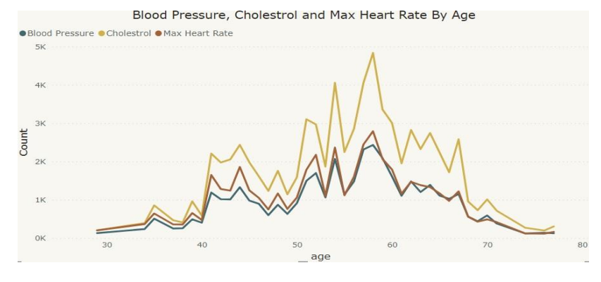

➢ Here we can observe that Blood Pressure increases between age of 50 to 60 and somehow continue the pattern till 70.

➢ Similarly, Cholesterol and maximum heart rate Increasing in the age group of 50-60.

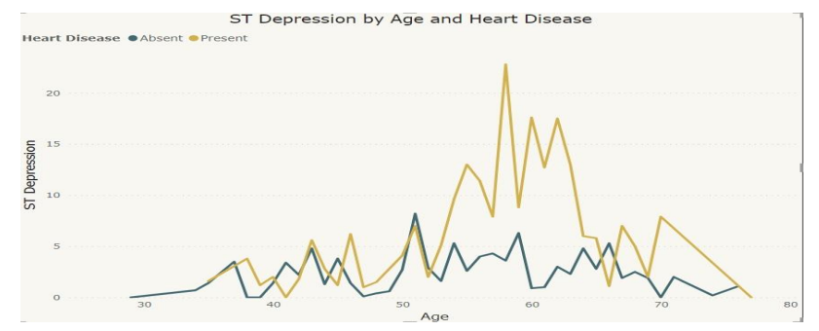

➢ we can observe from here that ST depression mostly increases between the age group of 30-40.

➢ ST depression refers to a finding on an electrocardiogram, wherein the trace in the ST segment is abnormally low below the baseline.